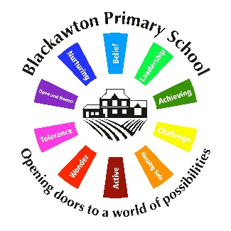Blackawton Primary School expectations and behaviour code (pupils and staff)

Aim
The ‘Blackawton Way’ underpins our Behaviour Policy. It is our aim that all children will be active and independent learners and thrive within an environment that both supports and challenges every child to succeed. We have high expectations of the pupils and ourselves. We want every child and their parents and carers to know that we care. We show this through the school environment, our expectations, our marking and feedback and the way we communicate with the children.

Behaviour Management and Behaviour Leadership
Behaviour management is essential for creating a safe, respectful environment for learning where children can succeed. This is a reflective process that is based on high expectations and clear consistent actions.

Behaviour Leadership recognises that behaviour management is not merely a process of following a set of rewards or sanctions. It is about treating each individual fairly recognising their basic needs and in doing so modelling expected behaviour. This is done with the aim of creating an equivalent culture of care and justice among children.

Rewards
These are responsive to the behaviour and are flexible within each class. Rewards are given in line with our high expectations for behaviours and for learning.

We celebrate, as a community, children’s responses to the ‘Blackawton Way’ – coloured wristbands and certificates reward achievement of one of the 9 principles of the ‘Blackawton Way’.

In line with our Teaching and Learning Policy, effort and application is praised rather than outcomes.

Consequences
As a community, we have agreed the following consequences when positive choices are not made. In all circumstances, it will be made clear why the current behaviour is not in line with the ‘Blackawton Way’.

- A verbal warning – ‘this is a choice that you have made’
- Move the person within the room
- Move the person to a link class for ten minutes
When choices that a child has made require steps 1 to 3 being used, a conversation must be had with the child to talk through their learning behaviours and any further consequences negotiated.

Further consequences include:
- Loss of playtimes
- Sent to the Head or person Acting Up
- Discussion with Parents
- Exclusion – Temporary or Permanent

Behaviour Support Plan
Where a child’s behaviour is such that this Behaviour Policy does not meet their needs, an Individual Behaviour Support Plan (BSP) will be written with children and parents.

